(On Non- Judicial Stamp Paper of Rs. 100/-)

**NATIONAL HEALTH MISSION, ASSAM**

**SURETY BOND**

This Deed of Bond Is made on ……………………………… day of ……………..…………..……...……………………. 2021.

Know all men by these present that we, Mr./ Mrs./Miss …………………………………….……………………...

S/D/W of Mr./Mrs. ……………………………………………………………………………… residing at ……………………….………………………………………………………………………………………. (**hereinafter called the** **Candidate”)** and (2) Mr./Mrs./Miss………………………………………………………………………………… S/D/W of Mr./Mrs.…………………………….……………………………………………………………residing at ………………………………….

**(hereinafter called the Surety”)** do hereby bound ourselves and our respective heirs executors and administrators, to the Mission Director, ASSAM Health Mission Society **( hereinafter called the “NHM”) on** demand **Rs.1,00,000/-** in respect of the **Candidate’s** Bridge Programme Certificate in **Community Health (hereinafter called the Programme”).**

Signature and delivered this ……........... Day of …………………………………Month ………………………………Year

Signature------------------

Signature____________

(Candidate)

(Surety)

WHEREAS on his/ her request, the Competent Authority at National Health Mission, Assam has selected the Candidate for the Programme conducted by the Indira Gandhi National Open University (IGNOU) commencing from the 10th May, 2021 and offered the candidate with sponsorship for undergoing the same vide letter of offer dated 09/04/2021 to 13/04/2021.

Now the condition of above written bond is that Candidate (i) shall successfully complete the Programme, and (ii) shall serve under National Health Mission, Assam thereafter for a minimum period of three(03) years after successful completion of the **Programme( hereinafter referred to as the “Bond Period”), whereas if the candidate shall** serve National Health Mission, Assam thereafter for a minimum period of three(03) years, then the above written bond shall lapse otherwise it shall be and remain in full force valid.

That further or in the alternative another condition of the above bond is that if the Candidate commits any breach of his/ her undertakings for whatsoever reasons or in case he/she fails to complete the Programme Successfully and/or serve the National Health Mission, Assam for the stipulated Bond Period thereafter, he/she and his/her surety shall jointly and severally compensate the National Health Mission, Assam for IGNOU fee (Covers study materials and counseling fee), boarding and lodging, transport expenses, etc. paid during the Programme period and expenses incurred by it on account of and in connection with the Programme and this amount will be recovered from him/her and/or from his/her surety. However, the total amount recoverable under this clause shall not exceed Rs 1,00,000/- (One lakh rupees only).

Signed jointly and severally by each of us on this ………………………..Day of …………………………………Month …………………………………………year in the presence of the following witnesses:

|  |  |  |  |  |
| --- | --- | --- | --- | --- |
|  | **Witnesses** | | (Candidate) Signature | (Surety) Signature |
|  | Signature- ………………………………… | | Signature - …………………………………… | Signature - ………………………………. |
|  |  |  |  |  |
|  | Name:______________________ | | Name:________________________ | Name :________________________ |
|  |  |  |  |  |
|  | Mobile No. | | Mobile No. | Mobile No.: |
|  |  |  |  |  |

Attested by Notary Public

**TERMS AND CONDITION OF SELECTION AS “CANDIDATE”**

1. **Bridge Programme**

1.1 Candidate will undergo Bridge Programme Certificate in Community Health conducted by the Indira Gandhi National Open University (IGNOU) (**hereinafter referred to as “Programme”**), which is a programme of six months duration. The candidate shall complete the programme successfully in all aspects within the stipulated six months period or within the extended period as per IGNOU norms.

1. **Maximum Limit of Sponsorship:-**

2.1 Candidates shall be provided support for IGNOU fee (covers study materials and counseling fee), boarding and lodging, transport expenses, etc as part of the sponsorship for the Programme, as per applicable norms. However, this support will be provided only for one tenure (i.e. the period from commencement of the course till the final Term End Examination conducted for the concerned batch by IGNOU for the first time). No support shall be provided to the candidate for any successive attempts to successfully complete the Programme.

1. **No Permanent Absorption in the NHM**

3.1 After successful completion of the Programme, the Candidate will be eligible for deployment as Community Health Officer (CHO) at Health &Wellness Centre (HWC)/Sub Centre.

3.2 The deployment of the Candidate as CHO will be purely on contractual/ conditional basis and the candidate will have no right to claim for appointment on permanent roll in State Health Department or permanent absorption. However, this clause is not applicable to candidates who are already regular employee of State Health Department / on permanent role of the State.

3.3 Contractual/ Conditional placement and posting thereof to any Sub Centre/ Health& Wellness Centre within the State will be at the discretion of the Competent Authority.

3.4 Honorarium for CHO:-Candidate, upon deployment as CHO, may be paid additional honorarium/ incentive for duration of his/ her tenure as CHO.

1. **Surety Bond**: The Candidate shall sign and submit a Surety Bond in the prescribed format on Rs. 100/-Stamp Paper (non- judicial) to complete the Bridge Programme (Certificate) in Community Health and to serve the National Health Mission, Assam at the discretion of the competent authority to serve any other clinic/ hospital/nursing centre etc. of the National Health Mission, Assam for at least three (03) years after successful completion of the Programme.

In case the Candidate fails to complete the Programme successfully ( within the programme period agreed by the competent authority, including, extension, if any )and /or serve the National Health Mission, Assam for the stipulated period of three(03) yea**rs thereafter , candidate, and Candidate’s surety shall** jointly and severally compensate the National Health Mission, Assam for IGNOU fee, boarding and lodging, transport expenses etc. paid during the Programme period and expenses incurred by it on account of and in connection with Programme and this amount will be recovered from Candidate and/or his/her surety, if Candidate leaves the National Health Mission, Assam within the Programme /bond period.

However, the total amount recoverable under this clause shall not exceed Rs 1,00,000/- (One lakh rupees only).Further candidate will be required to serve one-month advance notice while on contractual/ conditional employment, or pay salary (notice pay) in lieu thereof in addition to fulfilling the obligations stipulated in the Service Agreement Bond/ Norms of the National Health Mission, Assam. Candidate may note that Candidate shall not be applying for the Programme without the Surety Bond completed in all respects.

4.1 Candidate shall not be released during the Programme period or during the period of operation of Surety Bond for any employment elsewhere. Candidate shall not apply for employment elsewhere during the Programme period or bond period thereafter, without the prior permission of competent authority. In case Candidate has already applied and/or appeared in any such test, interview etc. before joinin**g for the Bridge Programme, in the event of Candidate’s** selection, Candidate shall not join the new organization, unless Candidate has fully complied with the terms and conditions of the Surety Bond.

1. Along with acceptance of the offer, the Candidate is required to submit the duly filled application
   * + - of admission to the Bridge Programme (Certificate) in Community Health (to be obtained from the
         * IGNOU Programme Prospectus) along with following documents: -
         * Original mark sheets & certificates as per the eligibility criteria as mentioned in the advertisement
         * Attested copies of mark sheet and certificate of relevant qualification as per the eligibility criteria as mentioned in the advertisement
         * Attested copies of matriculation certificate/admit card in support of candidate’s age
         * Registration of State Nursing Council (as per need)
         * Copy of caste certificate (if the candidate belongs to SC/ST/OBC category)
         * Post qualification experience certificate
         * 2 recent passport size photographs
2. **General**

The Candidate will anytime be subject to the terms and conditions of his/ her employment, including the Conduct, Discipline etc. and such other rules and administrative orders that may be in force from time to time during the Bridge Programme.

**Candidate’s selection is subject to:**

Candidate should not be suffering from any medical disability or illness, **which is likely to hamper Candidate’s selection, including posting** (after successful completion of Bridge Programme) at Sub Centers/ Health& Wellness Centers. In case it is detected at a later stage that Candidate had concealed any information pertaining to **Candidate’s medical status,** National Health Mission, Assam will be forced to cancel the offer of selection. In case of such evidence coming to light after **Candidate’s joining, Candidate’s services (Contractual / conditional) will be liable for** termination without notice at any time and Candidate will accordingly cease to be in the employment (Contractual/ conditional) of the National Health Mission, Assam.

* 1. 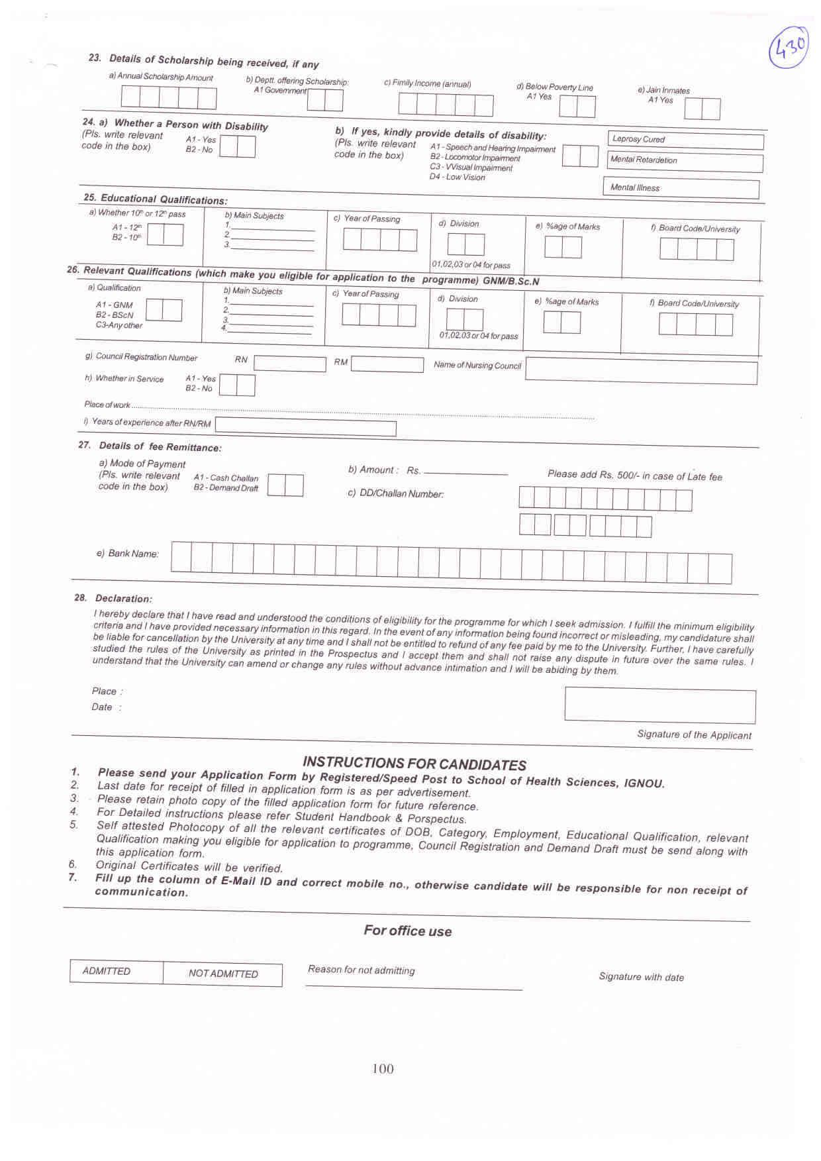Posting under the National Health Mission, Assam are transferable. Health Mission Society reserves the right to post Candidate at any of its Sub Centers/ Health& Wellness Centers within the State, if needed.
  2. The offer of selection is liable to be withdrawn at any point before joining and if joined, liable for termination without notice if competent authority comes across any evidence/ knowledge that the qualification , caste category and or any other particulars indicated by the candidate in his/her application/ personal resume/ other forms/ Formats submitted to the competent authority are not recognized/ false/ misleading and/or amounts to suppression of information/ particulars/ facts, which should have been brought to the notice of competent authority.
  3. Inadvertent omission or commission or mistakes, if any, appearing in the offer of selection are liable to be rectified at any time before or after joining to bring the terms and condition of offer in accordance with the extant policy/ rules and regulations of the National Health Mission, Assam that may be in force from time to time.
  4. The above terms and conditions are not exhaustive and this offer is subject to the understanding that during period of Programme and subsequent service (Contractual/ conditional), Candidate will be governed by the relevant rules, regulations and administrative orders that are framed from time to time.
  5. As the Programme is conducted for a whole batch, and not for individual candidate, extension in joining time will not be granted formally as no deferred batch is planned. Hence, the candidate should join on the scheduled date itself. Else, the offer may be subject to cancellation and withdrawal without further notice to the candidate. However, the competent authority/ MD, NHM may grant suitable extension in joining time on a case to case basis.
  6. Candidate will honor and observe the National Health Mission, Assam vision, mission and values at all times to maintain high esteem of the National Health Mission, Assam.

1. **Legal Matters**

Any legal proceeding in respect of any matter of claim or dispute arising out of this offer of selection shall be instituted in the courts at Guwahati, Assam only.

(a) Candidate is required to put his/her signature on each page at bottom right side.